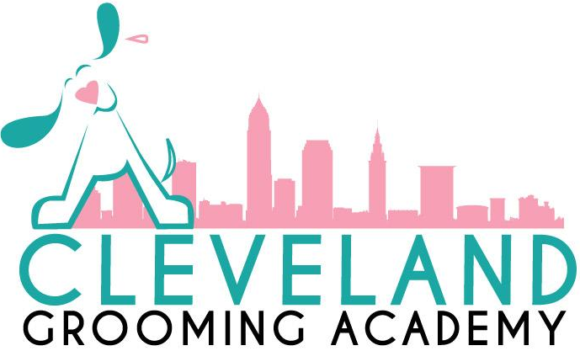
8183 Avery Road
Broadview Heights OH, 44147
Phone: 440-382-1320
Email: Clevelandgroomingacademy@gmail.com
Website: www.clevelandgroomingacademy.com

Ohio State Board Registration Number: 2107

Instructor: Arielle Scavnicky
Professional Pet Groomer and Instructor
Ohio Professional Pet Groomer’s Association President
NDGAA NCMG
AKC MG
Owner and Director

Printed: August 2023 (2024 Edition)

Cleveland Grooming Academy
8183 Avery Road Broadview Heights OH, 44147, (440-382-1320)
ENROLLMENT AGREEMENT
Student Name: Date:
Address: Apt:
City, State, Zip Code:
Home Phone: Work: Cell:
Social Security Number:
Driver’s License Number: State Issued:
Email Address:
Complete Basic Grooming Course
Tuition and Fees |  | Payment
Registration Fee:  Tuition Fee:  Equipment Cost  Total: | $100.00  $4,500.00  $1,800.00  $6,400.00 | Registration fee of $100.00 must be submitted with this enrollment form. Payment is due prior to the start of classes each term.

The total projected cost of this program at current rates and fees: $6,400.00
Tuition and fee charges are subject to change at the school’s discretion. Any tuition or fee increases will become effective for the school term following student notification of the increase.

Program: Complete Basic Grooming Start Date:
Program Length: 300 Clock Hours, this course is completed in 10 calendar weeks
*Courses are run every 11 weeks. Each course is 10 weeks, followed by a 1-week break. Classes resume immediately after break.
Program Description:
This program is a 10-week, 300-hour course. It is specially designed to include everything necessary to start your career as a successful dog groomer. Students will complete this course by having scheduled classroom times of 9:00am-3:00pm, Tuesday-Saturday. Each day includes one 30 min lunch break, which is not included in counted clock hours. At the end of each day, students will be required to clean the salon. Clean up time is also not included in clock hours.
30 Clock hours of Theory
270 Clock hours of Hands on Grooming

Cancellation and Settlement Policy:
- An enrollment or registration contract signed by the student and/or parent or legal guardian may be cancelled within five calendar days after the date of signature. The Cleveland Grooming Academy must be notified of cancellation in the form or a written and signed document.
- The Cleveland Grooming Academy will promptly refund in full the registration fee and any other charges paid plus any advanced tuition fees collected. Refunds will be issued no later than thirty (30) days after written document of cancellation is received.
- After five (5) days from the day the agreement was signed, but before the school term starts the student will receive a full refund of all fees paid, except for the registration fee.
- Last day of student attendance will be considered the withdraw date for any refund calculations.

Refund Policy:
If the student is not accepted into the grooming academy, all monies paid by the student shall be refunded. The Cleveland Grooming Academy uses the refund policy as established by the Ohio Administrative Rule 3332-1-10.
50-300 Clock Hours per term, quarter, or semester
- Clock hours are based on the 300-hour course by percentage of clock hours.
- A student who withdraws before the first class after the 5-day cancellation period shall be obligated for the registration fee.
- A student who starts class and withdraws before the academic term is 15% completed, will be obligated for 25% of the tuition, and refundable fees, plus the registration fee.
- A student who starts class and withdraws after the academic term is 15% completed but before the academic term is 25% completed, will be obligated to 50% of the tuition, and refundable fees, plus the registration fee.
- A student who starts class and withdraws after the academic term is 25% completed, but before the academic term is 40% completed, will be obligated for 75% of the tuition and refundable fees, plus the registration fee.
- A student who starts class and withdraws after the academic term is 40% completed, will not be entitled to a refund of the tuition or fees.

Complaint or Grievance Procedure:
All student complaints should be first directed to the school personnel involved. If no solution is forthcoming, a written complaint shall be submitted to the director of the Cleveland Grooming Academy. If the student feels no resolution has been made after the submission of a written complaint, they may direct any problems to the State Board of Career Collages and Schools, 30 East Broad Street, Suite 2481, Columbus OH 43215-3414 Phone: (614)-466-2752 or toll free (877)-275-4219.
I agree that I have received a Collage Catalog and agree with the school policies and procedures that have been stated. I acknowledge that I have received and read a copy of this agreement.
Applicants Signature: Date: _
Parent or Guardian (if applicable): Date:
School Representative: Date:

